Introduction
This document describes the source code CID_2_01.src.
In the past, such telephony functions as FSK (frequency-shift keying) generation and detection, DTMF (dual-tone, multi-frequency) generation and detection, and Caller ID could not be implemented with an 8-bit embedded MCU because performance levels were not high enough to support them. As a result, either a custom MCU had to be designed or a 16- or 32-bit device used. Now, the 8-bit Scenix Semiconductor SX Series MCUs, which have performance reaching 100 MIPS (million instructions per second) and a deterministic interrupt architecture, overcome this roadblock by providing the ability to perform these functions in software.
Unlike other MCUs that add functions in the form of additional silicon, the SX Series uses its industry-leading performance to execute functions as software modules, or Virtual Peripherals. These are loaded into a high-speed (10 ns access time) on-chip flash/EEPROM program memory and executed as required. In addition, a set of on-chip hardware peripherals is available to perform operations that cannot readily be done in software, such as timers, comparators, and oscillators.
Caller-ID is a method of providing telephone users with a way of knowing from whom an incoming call originates. It is a signal which is broadcast as the phone begins to ring (It is sent before the first ring in Europe and between the first and second rings in North America.) A Caller-ID box receives the incoming Caller-ID data, stores it, and outputs the caller's name and number on a display.
Caller-ID is transmitted as an FSK signal. FSK is a form of modulation used to transmit digital data over analog telephone lines. FSK stands for Frequency Shift Keying, and it uses frequency- shifts to transmit data. Since binary data is stored as '1's and '0's, there are two frequencies used for Frequency Shift Keying; one frequency symbolizes high data, and the other frequency symbolizes low data. A transmitted signal is modulated by a bitstream of 1200bps, with the frequency of the sine wave alternating as the data bits are modulated onto the carrier.
VP's included with the Caller-ID software include:
- FSK receive
- 64-byte buffer
- RS-232 receive/transmit @ 1200 baud
The Firmware:
To demodulate the incoming Caller-ID signal, the Scenix modem uses an extremely simple and effective zero-cross algorithm. As the frequency shifts from high to low and back to high, the FSK-receive pin sees logic shifts at varying intervals. The software simply times the transitions on the input pin. A longer transition means a lower frequency, and vice versa.
Since the FSK-receive software runs completely in an interrupt service routine, it is completely transparent to the mainline routine. The mainline routine is left to do processing on the incoming signal, and there are gobs of processing power left over to perform this task.
The mainline routine simply loops and awaits an incoming FSK byte (signified by the setting of a flag.) Once a Caller-ID byte is received, it is compared to the standard header for Caller-ID, multiple ASCII 'U's. Once it is found that this is, in fact, a Caller-ID packet, the routine waits until it receives a header for one of the known packets: date, time, name, or number. When a header is received, the data packet is stored into a 64-byte buffer.
The routine continues to look for incoming Caller-ID until a RING is detected, signifying the end of the Caller-ID packets. At this point, the mainline routine begins sending the contents of the 64-byte buffer serially.
The Hardware
These are the I/O pins used for the Caller-ID software.
PWM_pin equ ra.0 ; PWM output for D/A
rx_pin equ ra.1 ; RS-232 Input pin
tx_pin equ ra.2 ; RS-232 Output pin
in_out equ ra.3 ; Switches between output
; and input on SX DTMF DEMO boards.
led_pin equ rb.0 ; Flashes to indicate that program
; is running
ring equ rb.3 ; Ring detection pin
hook equ rb.4 ; Goes on/off-hook.

Signal Conditioning:
FSK Input:
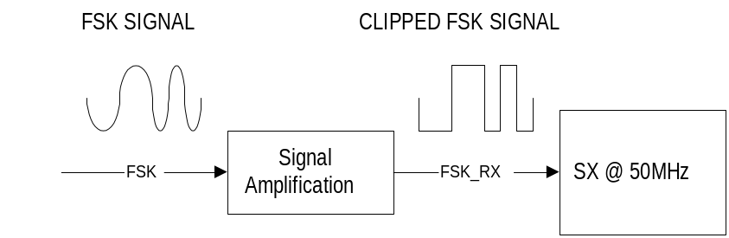The software implementation of FSK detection is very simple. The transitions on the input pin are timed by the software. If the transitions occur within a specified time, then a high frequency is being detected, otherwise a low frequency is being detected.
Since the software uses a Schmidtt Trigger input on the SX, the input FSK signal must be amplified until clipping to trigger the Schmidtt Trigger levels.
The current reference design is on the web. Keep in touch with www.scenix.com for any updates we make available.

